**Assisting a client in choosing a strategic area to setup a new Coffee Shop in West Toronto**

Abbas Hassan

January 28, 2020

1. **Introduction**
   1. **Background**Toronto is a city which reveals itself over time. It grows on people until they suddenly realize that there is nowhere else in the world they would rather be. There are many cultures, cuisines and the city just produces better restaurants. The city is incredibly foot friendly whether you are just going for a gentle walk or attending nice local venues in the area. Setting up a new Coffee Shop in a strategic location will depend on numerous factors which contribute to a location being “strategic”.
   2. **Problem**The problem that we are trying to address is finding a strategic area to setup a new Café in West Toronto. As you can imagine, we would need to assess all the available neighbour hoods in the area and better understand the trending venues in relevant areas before we can make a recommendation.
   3. **Interest**   
      This would be very interesting to small Coffee Shop business owners who would want to grow their business. However this could also benefit new starters who have a passion for running their own first Coffee Shop and need a guidance to where a strategic neighbourhood might be.

1. **Data acquisition and cleaning**For the Toronto neighbourhood data, a Wikipedia page exists <https://en.wikipedia.org/wiki/List_of_postal_codes_of_Canada:_M>) that has all the information we need to explore and cluster the neighbourhoods in Toronto. We will need to first clean the data, and then read it into a pandas dataframe so that it is in a structured format. There were a lot of missing coordinates despite using the geo locator so I decided to focus on West Toronto which was most complete. The cleaned data has 4 boroughs and 39 neighbourhoods. The data is then further cleaned by focusing on West Toronto.

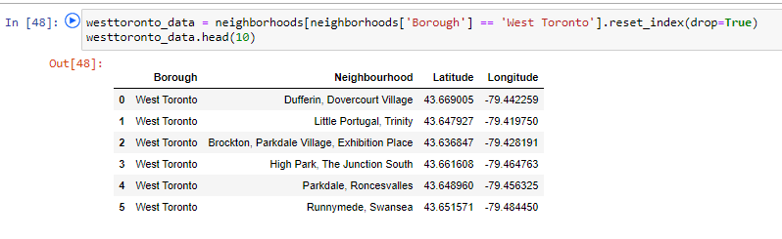

The below displays a map of our data using the folium library We will be using the above mentioned data source to find a strategic neighbourhood to setup a new Coffee Shop.

